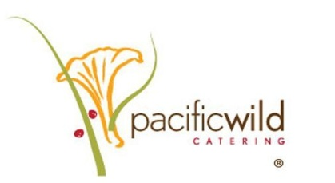
Apply on aramark.com/careers.
Search the city/state of Portland Oregon or by job number. Click on the position you are interested, review the job description and apply!!
Oregon Convention Center
- Steward (General Utility Worker) 14.50 hourly job 188257
- Banquet Cook 16.50 hourly rate job 188005
- Prep Cook (Food Prep Worker) 15.00-15.25 hourly rate job 188453
- Concession Cook 17.50 hourly rate job 188420
- Pastry Prep Cook (Baker) 15.25 hourly rate job 175451
- Pastry Cook (Baker) 16.80 hourly rate job 188447
- Lead Pastry Cook 18.80 hourly rate job 181841
- Barista 13.25 hourly rate job 172911
- Lead Barista 14.75 hourly rate job 186850
- Stand Worker 13.75 hourly rate job 188006
- Lead Stand Worker 15.75 Hourly rate job 180950
- Culinary Operations Supervisor- job 183953*
Portland5 Centers for the Arts
- Prep Cook 13.50 hourly rate job 182032
- Restaurant/Catering Server 12.00 hourly rate job 189032
- Dishwasher 13.00 hourly rate 184412
Portland Expo Center
- Restaurant Server 12.00 hourly rate job 184229
- Restaurant/Catering Bartender 12.50 hourly rate job 184243
- Concession Stand Worker/Beer Pourer 12.35 hourly rate job 184225
- Warehouse Runner 13.00 hourly rate job 184223
- Lead Warehouse Runner 14.25 hourly rate job 184242
- Steward (General Utility Worker) 13.00 hourly rate job 184216
- Restaurant Cook 14.50 hourly rate job 183874
- Lead Stand Worker 13.50 hourly rate job 184221
------------------------------------------------------------------------------------------------------------------------------------------------------------------------
- Minimum age: 18 years old
- Valid Food Handler Card for all positions; must have the card by first scheduled shift
- Valid OLCC card for server, bartender, stand worker, warehouse runner and host, must have applied for/have card by first scheduled shift
- Ability to work part time/event based schedule; availability to include evenings and weekend
- All Food Beverage Service Workers are represented by UniteHERE Local 8, unless noted with *

